SIMATS ENGINEERING

ASSESSMENT TOOL 3: Reverse Engineering Task

COURSE NAME: | Cloud Computing and  Big Data Analytics | COURSE CODE: | CSA1508

COURSE OUTCOME COVERED
CO4: Analyze big data characteristics and challenges across domains including security and application aspects.
(BL4)

Dave's Taxonomy: Articulation (Level 4)  Question Count: 5 | Total Marks: 30

Code of Conduct
I P.Muni Lokesh(192372181)(Name / Reg. No.) certify that this submission is my original work and that I have adhered to the guidelines specified for this assessment.
I understand that any violation of academic integrity rules will result in disciplinary action. Signature of the student: P.MuniLokesh

Assessment Tasks Reverse Engineering Task
For each task, study the described big data solution, infer how it was built, identify the underlying components, and explain what design decisions were likely made.

- A big data platform collects billions of website clicks, mobile interactions, and customer transactions every day. Reverse engineer the probable distributed storage system, ingestion framework, and batch-processing tools used. Infer how structured and semi-structured data are separated and indexed for analysis. Identify the likely stream-processing engines supporting real-time analytics and reporting. Explain the scalability and partitioning strategies probably implemented for handling massive workloads. Describe how dashboards and business intelligence systems are likely connected to the analytics layer.
Answer:
A platform of this scale — billions of clicks, mobile interactions, and transactions per day — cannot be reverse engineered as a single monolithic system. The scale alone (terabytes ingested daily) rules out a traditional single-server relational database for raw storage, and the mix of real-time reporting with historical analysis strongly implies a two-speed (lambda-style) architecture: a slower, complete batch path and a faster, approximate streaming path that are reconciled downstream. The inferred pipeline below reflects that reasoning.

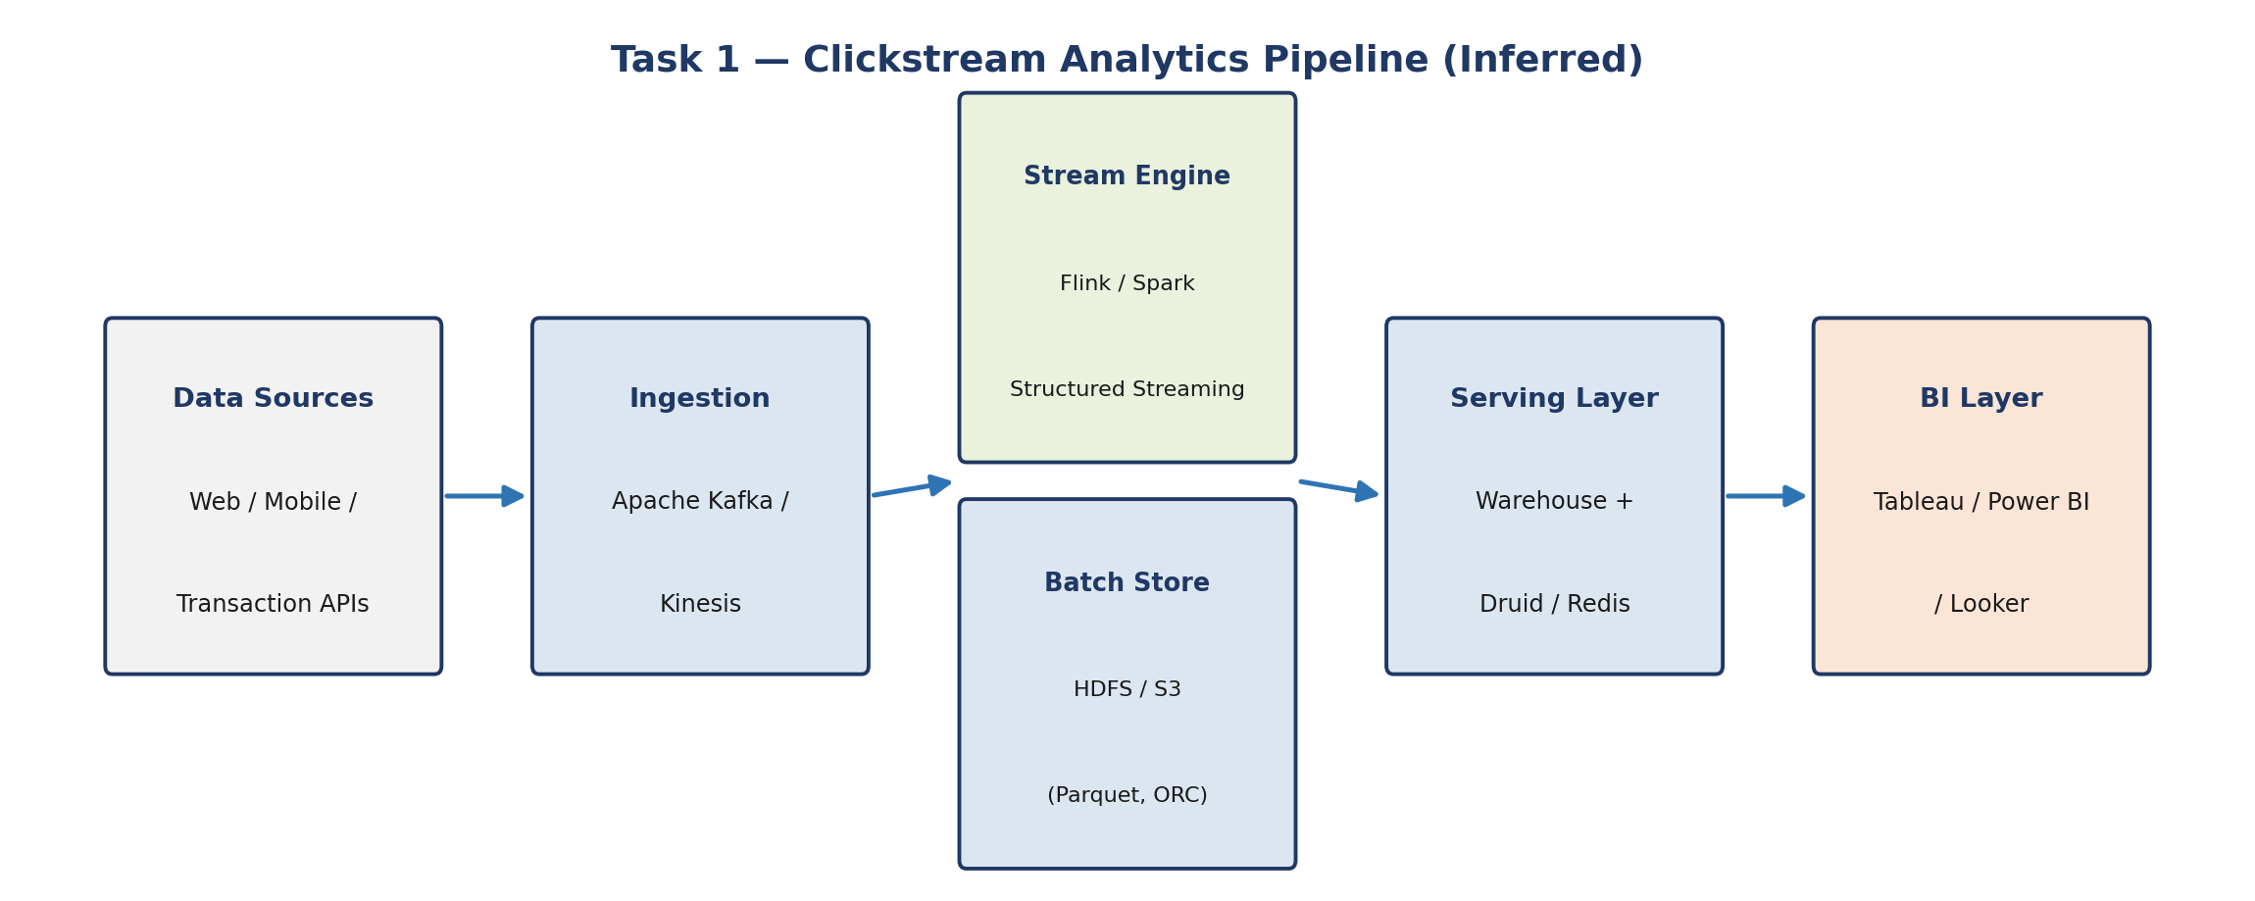

Storage, Ingestion, and Batch Processing
A platform ingesting billions of clicks, mobile events, and transactions daily most likely rests on a distributed file system such as HDFS or a cloud object store (Amazon S3, Azure Data Lake Storage, or Google Cloud Storage) as the durable landing zone, because these systems scale horizontally and tolerate node failure without data loss. Ingestion is probably handled by Apache Kafka or a managed equivalent (Amazon Kinesis, Google Pub/Sub) acting as a durable, replayable buffer between producers (web/mobile SDKs, transaction services) and downstream consumers, decoupling data generation from data processing. Batch processing of the accumulated raw data likely runs on Apache Spark or Hadoop MapReduce, scheduled through an orchestrator such as Apache Airflow, to produce cleaned, aggregated datasets.

Separation and Indexing of Structured/Semi-Structured Data
Structured data — validated transaction and account records — is inferred to be modeled into columnar formats (Parquet/ORC) and loaded into a data warehouse layer (e.g., Snowflake, BigQuery, or Hive tables) with defined schemas and indexes for fast SQL analytics. Semi-structured data (JSON click events, nested mobile telemetry) is likely stored schema-on-read in the data lake and indexed using metadata catalogs (Hive Metastore, AWS Glue Catalog) or search indexes (Elasticsearch) for flexible querying, since enforcing a rigid schema on high-velocity event data upfront would be costly and brittle.

Stream Processing for Real-Time Analytics
Given the requirement for real-time reporting, the platform probably runs Apache Flink, Spark Structured Streaming, or Kafka Streams consuming directly from the Kafka topics to compute rolling metrics (active users, conversion counts) with low latency, feeding results into a fast-access store (Redis, Apache Druid, or Cassandra) for dashboards.

Scalability and Partitioning
- Horizontal partitioning: Kafka topics and HDFS/S3 data are likely partitioned by time (date/hour) and by logical key (user ID, region) to parallelize both ingestion and query pruning.
- Consumer group scaling: Stream consumers probably scale elastically by adding partitions/consumer instances as load grows.
- Replication and fault tolerance: Data is likely replicated (3x in HDFS, multi-AZ in cloud storage) so node loss does not interrupt processing.

Dashboard and BI Connectivity
Business intelligence tools (Tableau, Power BI, Looker) most likely connect to the curated warehouse tables or to an OLAP layer (Druid/ClickHouse) rather than directly to raw event streams, since this insulates dashboards from pipeline volatility and keeps query latency predictable for business users.

Technical Evidence Supporting This Inference
- Throughput requirement: billions of events/day is roughly tens of thousands of events per second sustained, a workload class Kafka is specifically benchmarked and designed for, whereas a traditional message queue (RabbitMQ) would need heavy clustering to cope.
- Cost-efficiency of columnar formats: Parquet/ORC compress well and support predicate pushdown, cutting both storage cost and scan time for analytical queries over years of history — a strong incentive at this data volume.
- Separation of concerns: keeping the raw immutable log (data lake) separate from the serving layer (warehouse/OLAP) is a widely adopted pattern precisely because it lets teams reprocess history when business logic changes without re-ingesting from source systems.

Additional Design Considerations
A few further inferences round out the picture. Schema evolution is a near-certainty at this scale — mobile app versions and web tracking scripts change constantly — so a schema registry (e.g., Confluent Schema Registry) is likely paired with Kafka to prevent malformed events from silently breaking downstream jobs. Data quality checks (row counts, null-rate monitoring) are probably automated within the Airflow DAGs rather than manual, since human review of billions of daily rows is infeasible. Finally, cost governance likely plays a role in the design: cold, rarely queried historical partitions are probably moved to cheaper storage tiers (S3 Glacier or infrequent-access classes) while recent hot data stays on faster storage, balancing query performance against storage spend.

- An e-commerce platform tracks cart additions, abandoned checkouts, product views, and payment behavior across regions. Reverse engineer the likely event streaming tools, customer profiling databases, and recommendation workflow used. Infer how session data, clickstream logs, and transaction records are synchronized for real-time personalization. Identify probable caching systems, distributed query engines, and machine learning stages involved. Explain how structured order data and semi-structured browsing data are merged for analytics. Deduce the scalability and fault-tolerance decisions likely implemented. Describe how dashboards and KPI monitoring are probably generated from the pipeline.
Answer:
An e-commerce platform's defining constraint is latency: personalization only has value if it reacts within the same browsing session, not the next day. That single requirement is the strongest clue to the architecture — it forces a real-time feature-serving path alongside the usual batch analytics path, and it explains why session identity, not just user identity, becomes a first-class concept in the data model.
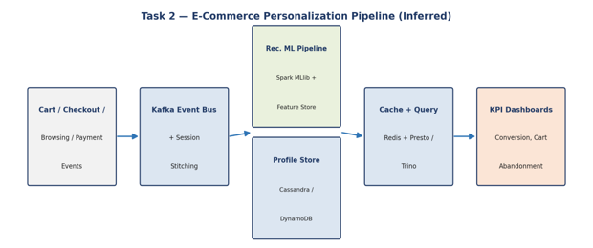
Event Streaming, Profiling, and Recommendations
Cart, checkout, browsing, and payment events point to an event-streaming backbone (Kafka) feeding a customer profile store, likely a NoSQL database such as Cassandra or DynamoDB chosen for its low-latency key-based reads/writes at scale. The recommendation workflow probably follows a lambda-style pattern: batch model training (Spark MLlib or a managed ML service) on historical purchase/browse data, with a real-time feature/serving layer (Redis or a feature store) supplying live signals to the model at request time.
Synchronizing Sessions, Clickstream, and Transactions
Session stitching is likely achieved by tagging every event with a common session/user identifier propagated across services, with a stream processor (Flink/Spark Streaming) joining clickstream and transaction topics within time windows to reconstruct a unified customer journey for personalization in near real time.
Caching, Query Engines, and ML Stages
- Caching: An in-memory cache (Redis/Memcached) likely fronts product catalogs and session state to keep page loads fast.
- Distributed query engines: Presto/Trino or Spark SQL probably support ad-hoc analytical queries across the lake without moving data.
- ML stages: Feature engineering, offline training, and online inference are likely separated into distinct pipeline stages so model updates do not block live traffic.
Merging Structured and Semi-Structured Data
Order and payment records (structured, relational) are probably joined with browsing logs (semi-structured JSON) through an ETL/ELT layer that lands both in a common lake format (Parquet) keyed by customer/session ID, enabling unified analytics without forcing clickstream data into a rigid relational schema.
Scalability and Fault Tolerance
Regional sharding of the profile database, auto-scaling stream consumers, and idempotent event processing (to handle retries safely) are likely design choices, since e-commerce traffic spikes sharply during sales events and cannot tolerate downtime.
Dashboards and KPI Monitoring
KPI dashboards (conversion rate, cart abandonment, revenue per region) are probably generated from a curated metrics layer refreshed by both batch aggregation and streaming rollups, visualized through BI tools connected to a warehouse or OLAP store.
Technical Evidence Supporting This Inference
- Recommendation latency budget: product pages typically must render recommendations in under 100-200ms, which rules out querying a batch warehouse directly at request time and points strongly toward a precomputed or cached feature store (Redis) as the serving mechanism.
- Regional behavior: "across regions" implies the profile database is likely partitioned or replicated geographically (e.g., DynamoDB global tables or Cassandra multi-datacenter replication) to keep reads local and fast for users worldwide.
- Abandoned checkout tracking: detecting an abandoned checkout requires a session to be evaluated against a timeout window, which is a classic use case for stream-processing windowed aggregations rather than simple database triggers.
Additional Design Considerations
The recommendation workflow probably also includes an A/B testing or experimentation layer, since retailers typically validate new ranking models against control groups before full rollout — this implies the architecture tags each session with an experiment/variant ID that flows through the same event pipeline. Additionally, because payment data is highly sensitive, it is likely segregated into a more tightly access-controlled subsystem (tokenized card data via a PCI-DSS-compliant payment gateway) rather than sitting in the same open analytics lake as browsing events, even though both are eventually joined for analytics through anonymized or hashed identifiers.

- A big data healthcare system processes patient histories, diagnostic images, wearable sensor streams, and prescription records. Reverse engineer the probable hybrid database architecture managing structured and unstructured healthcare information. Infer the likely data integration tools connecting hospitals, laboratories, and insurance systems. Identify the streaming and machine learning

Answer:

Healthcare data is unusual among big data domains because its three major formats — structured records, large binary images, and continuous sensor streams — each demand a fundamentally different storage engine, and none can be substituted for another without a major performance or compliance penalty. That mismatch is the central clue for reverse engineering this platform: it almost certainly is not a single database, but a deliberately hybrid, polyglot-persistence design.

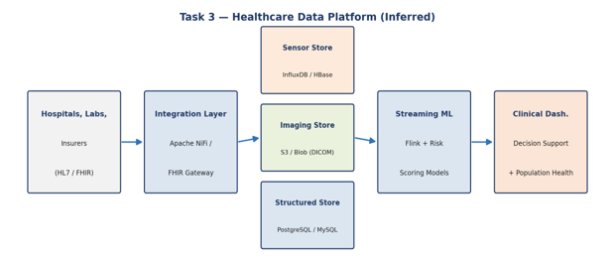

Hybrid Database Architecture
Because the data spans structured records (patient demographics, prescriptions), unstructured content (diagnostic images), and time-series wearable data, the platform is likely polyglot: a relational database (PostgreSQL/MySQL) for transactional patient and prescription records, an object store (S3/Azure Blob) for DICOM images with metadata indexed separately, and a time-series or wide-column store (InfluxDB, Cassandra, or HBase) for continuous sensor streams.
Data Integration Across Hospitals, Labs, and Insurers
Interoperability likely relies on healthcare-specific integration engines and standards such as HL7/FHIR APIs, with an ETL layer (Apache NiFi or a managed integration service) reconciling identifiers and formats across source systems before loading into the central platform.
Streaming and ML for Prediction and Monitoring
Wearable and vitals streams probably flow through Kafka into a streaming engine (Flink/Spark Streaming) that scores incoming readings against pre-trained models (e.g., anomaly or deterioration-risk detectors) to trigger real-time clinical alerts, while heavier imaging-based ML (e.g., diagnostic classification) likely runs as batch or near-real-time inference given its computational cost.
Privacy, Encryption, and Compliance
- Encryption: Data is likely encrypted at rest (AES-256) and in transit (TLS) given the sensitivity of health information.
- Access control: Role-based access control and field-level masking probably restrict who can view identifiable data, supporting HIPAA/GDPR-style compliance.
- Auditability: Comprehensive audit logging of data access is likely mandatory for regulatory reporting.
Clinical Decision and Population Health Pipeline
A curated analytics layer, fed by both batch (historical outcomes) and streaming (live vitals) pipelines, probably supports clinician-facing dashboards for individual decision support and separate aggregated views for population health research, kept isolated to prevent identifiable data from leaking into broader research datasets.
Technical Evidence Supporting This Inference
- Image size vs. record size mismatch: a single diagnostic scan can be hundreds of megabytes, while a patient record is a few kilobytes; storing both in the same relational table would be highly inefficient, which is why object storage with the image path/metadata referenced from the relational record is the standard industry pattern (used in real PACS/DICOM systems).
- Regulatory pressure: healthcare is one of the most heavily regulated big data domains (HIPAA in the US, similar frameworks elsewhere), which makes encryption, audit logging, and strict access control non-negotiable design elements rather than optional add-ons.
- Latency-criticality of alerts: a deteriorating vital sign has to trigger a clinical alert within seconds, which is only achievable with a streaming — not batch — evaluation path.
Additional Design Considerations
A disaster-recovery and business-continuity layer is also a near-certain requirement given that hospital systems cannot tolerate extended downtime; this likely means multi-region replication or hot standby databases. It is also probable that the platform applies data minimization by design — only the minimum necessary identifiable fields are exposed to any given downstream consumer (e.g., researchers likely see de-identified or pseudonymized data), which reduces breach impact and is a common compliance-by-design pattern in regulated data platforms.

- A smart city platform gathers traffic sensor feeds, CCTV metadata, weather updates, and public transport activity continuously. Reverse engineer the probable edge computing setup, distributed messaging system, and centralized storage design. Infer how geospatial analytics and streaming computations are handled for congestion prediction. Identify the likely databases used for time-series and location-aware queries. Explain how batch and real-time analytics are combined for urban planning insights. Deduce the security and access-control measures likely protecting citizen and infrastructure data. Describe how visualization systems probably deliver live operational intelligence.
Answer:
Smart city data has a distinctive property that most enterprise big data systems do not: it is generated by thousands of physically distributed devices with limited and variable network connectivity (traffic sensors, CCTV units), rather than by centralized application servers. That constraint is the strongest signal for inferring an edge-computing layer, since transmitting every raw frame of CCTV footage or every second of sensor data to a central cloud would be both bandwidth-prohibitive and latency-inducing for time-critical decisions like traffic signal adjustment.
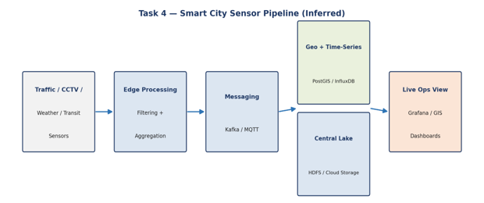
Edge Computing, Messaging, and Central Storage
Given continuous feeds from traffic sensors, CCTV, weather stations, and transit systems spread across a city, the platform likely performs initial filtering and aggregation at the edge (edge gateways or devices running lightweight processing) to cut bandwidth before transmission, publishes events to a distributed messaging system (Kafka or MQTT for IoT-style devices), and lands aggregated data centrally in a data lake (HDFS/cloud storage) for long-term storage and batch analysis.
Geospatial and Streaming Computation for Congestion Prediction
Congestion prediction probably combines a stream processor (Flink/Spark Streaming) computing rolling traffic-flow metrics with geospatial libraries or a spatial database extension (PostGIS, or geospatial functions in Spark) to correlate location-tagged sensor readings and generate near-real-time congestion forecasts.
Databases for Time-Series and Location-Aware Queries
Time-series databases (InfluxDB, TimescaleDB) are likely used for sensor and traffic-flow histories, while a spatial-capable store (PostGIS or a geospatial NoSQL layer) supports location-based queries such as nearest-sensor or route-corridor analysis.
Combining Batch and Real-Time Analytics
Real-time streams likely drive immediate operational alerts (e.g., incident detection), while nightly or hourly batch jobs probably compute longer-term traffic pattern models used for urban planning, with both layers converging in a shared serving store so planners can query historical trends alongside live conditions.
Security and Access Control
- Data protection: CCTV metadata and location data are likely anonymized or aggregated where possible to limit privacy exposure.
- Access control: Role-based access and network segmentation probably restrict raw feeds to authorized municipal systems.
- Device security: Edge devices likely use certificate-based authentication to prevent spoofed sensor data.
Visualization for Operational Intelligence
Live operational dashboards (built with tools like Grafana or a custom web GIS front end) probably pull from the streaming serving layer to render real-time maps of traffic, transit, and incident status for city operators.
Technical Evidence Supporting This Inference
- Bandwidth constraint: raw CCTV video across a citywide sensor network would run into petabytes per day if sent uncompressed to the cloud; edge pre-processing (extracting only metadata such as vehicle counts or license-plate events) is the only economically viable option at this scale.
- Heterogeneous device protocols: public-sector IoT deployments commonly mix legacy sensors and modern devices, which is why a lightweight, low-overhead protocol like MQTT (designed for constrained devices) is frequently paired with Kafka as the central backbone.
- Geospatial query pattern: "congestion prediction" implies queries like "which road segments near this point are congested," which is precisely what spatial indexes (R-trees in PostGIS) are optimized for, unlike a standard relational index.
Additional Design Considerations
Given multiple city agencies (transport, police, utilities) likely consume this data, a data governance and access-tiering model is probably in place, where each agency only receives the subset of feeds relevant to its mandate. It is also likely that the platform supports offline resilience at the edge — if the central network link drops, edge nodes probably buffer and forward data once connectivity resumes, rather than losing data outright, since public infrastructure monitoring cannot silently lose observability during network outages.

- A healthcare analytics system integrates patient records, wearable device readings, lab reports, and appointment histories. Reverse engineer the probable hybrid storage architecture handling sensitive structured and unstructured medical data. Infer the likely ETL pipelines and interoperability standards connecting hospitals and clinics. Identify how real-time monitoring and predictive health analytics are probably implemented. Explain the role of distributed processing frameworks in population-level analysis. Deduce the encryption, compliance, and audit mechanisms likely enforced for data governance. Describe how machine learning models may support diagnosis risk scoring and treatment recommendations.
Answer:
This scenario overlaps with Task 3 in data types but the emphasis shifts from clinical care delivery toward analytics and governance at population scale. The reverse-engineering signal here is the phrase "population-level analysis" combined with strict data-sensitivity requirements, which together point toward a platform optimized less for single-patient real-time response and more for large-scale, well-governed batch and streaming analytics across many patients simultaneously.
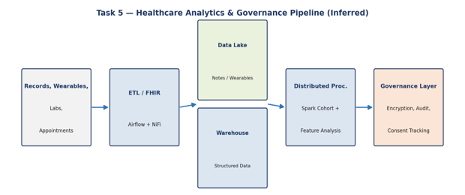
Hybrid Storage for Sensitive Medical Data
Similar to Task 3 but oriented toward analytics and governance, this system likely separates structured data (appointment schedules, lab result values) into a relational or data-warehouse layer, while unstructured/semi-structured content (clinical notes, wearable readings) is probably stored in a document store or data lake, unified through a common patient-identifier key across stores.
ETL Pipelines and Interoperability Standards
ETL pipelines likely use HL7/FHIR-based connectors and a workflow orchestrator (Airflow or NiFi) to pull data from multiple hospital and clinic source systems, standardizing codes (e.g., ICD, LOINC) so downstream analytics can compare data across providers consistently.
Real-Time Monitoring and Predictive Analytics
Wearable readings probably stream through Kafka into a processing layer that both stores raw history and feeds live values to rule-based or ML-based monitoring models, while predictive analytics for readmission or deterioration risk likely runs as periodically retrained batch models scored against incoming data.
Role of Distributed Processing Frameworks
Population-level analysis across potentially millions of patient-years of data likely requires distributed compute (Spark) to run feature extraction, cohort analysis, and model training at scale, since single-node processing would not handle the volume within useful timeframes.
Encryption, Compliance, and Audit Mechanisms
- Encryption: End-to-end encryption at rest and in transit is likely enforced across all storage and messaging layers.
- Compliance: Data governance policies probably enforce consent tracking, data minimization, and regional data-residency rules.
- Auditing: Immutable audit trails likely log every access and transformation for regulatory review.
ML for Diagnosis and Treatment Recommendation
Risk-scoring and treatment-recommendation models are likely trained offline on de-identified aggregated data and deployed as scoring services queried by clinical applications, with model outputs logged for clinician review rather than acting autonomously, reflecting the high-stakes nature of clinical decisions.
Technical Evidence Supporting This Inference
- Cross-provider standardization: different hospitals virtually always use different EHR vendors with incompatible internal schemas, so a common exchange standard (FHIR) is the only realistic way to integrate them without a costly one-off connector per source.
- Volume-driven need for distributed compute: cohort analysis across large patient populations involves joins and aggregations over datasets far larger than a single machine's memory, which is the textbook use case Spark was built for.
- Human-in-the-loop ML deployment: clinical AI systems are near-universally deployed as decision-support rather than autonomous decision-makers because regulatory bodies (e.g., FDA-cleared clinical decision support tools) require clinician oversight, reinforcing the inference that model outputs are advisory, logged, and reviewable.
Additional Design Considerations
A data governance board or equivalent process likely sits above the technical architecture, approving what aggregated data can be released for research and under what de-identification standard (e.g., HIPAA Safe Harbor or Expert Determination). It is also plausible that the platform maintains separate environments for operational analytics (near-real-time, identifiable, tightly access-controlled) and research analytics (batch, de-identified, broader access), since mixing the two would either slow clinical operations or over-expose identifiable data to a wider research audience than necessary.

Reverse Engineering Task Rubric
Criteria | Weightage | Level 4 - Exemplary | Level 3 - Proficient | Level 2 - Developing | Level 1 - Beginning | Total Marks
Inference Accuracy | 25% | Infers system components and flow  with high accuracy | Mostly accurate inference | Basic inference | Weak inference
Understanding of Architecture | 25% | Shows clear understanding of  underlying big data architecture | Good understanding | Partial understanding | Poor understanding
Use of Technical Evidence | 20% | Uses strong reasoning  and technical evidence | Reasonable evidence | Limited evidence | No meaningful evidence
Depth of Analysis | 15% | Analysis is deep and  insightful | Reasonably  deep | Basic depth | Superficial  analysis
Clarity | 15% | Clear and organized  explanation | Generally clear | Somewhat  unclear | Poorly  presented

